Relationship and sex education policy
Hallmoor School



Approved by: | Paul Donkersloot | Date: December 2024
Last reviewed on: | November 2024
Next review due by: | December 2025

Contents
1. Aims 3
2. Statutory requirements 3
3. Policy development 5
4. Definition 5
5. Curriculum 5
6. Delivery of RSE 6
7. Use of external organisations and materials 7
8. Roles and responsibilities 8
9. Parents’ right to withdraw 9
10. Training 10
11. Monitoring arrangements 10
Appendix 1: Curriculum map 11
Appendix 2: By the end of primary school pupils should know 12
Appendix 2: By the end of secondary school pupils should know 14
Appendix 3: Parent form: withdrawal from sex education within RSE 17

1. Aims
The aims of relationships and sex education (RSE) at our school are to:
- Provide a framework in which sensitive discussions can take place
- Prepare pupils for puberty, and give them an understanding of sexual development and the importance of health and hygiene
- Help pupils develop feelings of self-respect, confidence and empathy
- Create a positive culture around issues of sexuality and relationships
- Teach pupils the correct vocabulary to describe themselves and their bodies
- Prepare pupils at our school of the opportunities, responsibilities and experiences of later life;
- Promote British Values

2. Statutory requirements
Maintained primary schools insert:
As an all through (4-19) specialist academy school we must provide Relationships Education to all Primary aged pupils and we must provide Relationships and Sex Education to all Secondary age pupils up to the age of 16 as per section 34 of the Children and Social Work Act 2017.
We are not required to provide sex education, but we do need to teach the elements of sex education contained in the science curriculum.
In teaching RSE, we must have regard to guidance issued by the secretary of state, as outlined in section 403 of the Education Act 1996.
We must also have regard to our legal duties set out in:
- Sections 406 and 407 of the Education Act 1996
- Part 6, chapter 1 of the Equality Act 2010
- The Public Sector Equality Duty (as set out in section 149 of the Equality Act 2010). This duty requires public bodies to have due regard to the need to eliminate discrimination, advance equality of opportunity and foster good relations between different people when carrying out their activities
At Hallmoor, we teach Relationships Education (Primary) and RSE (Secondary) as set out in this policy.

3. Policy development
This policy has been developed in consultation with staff, pupils and parents/carers. The consultation and policy development process involved the following steps:
- Review – a member of staff or working group pulled together all relevant information including relevant national and local guidance

- Staff consultation – all school staff were given the opportunity to look at the policy and make recommendations

- Parent/stakeholder consultation – parents/carers and any interested parties were invited to attend a meeting about the policy

- Pupil consultation – we investigated what exactly pupils want from their RSE

- Ratification – once amendments were made, the policy was shared with governors and ratified

4. Definition
Here, at Hallmoor School, we value PSHE as one way to support children’s development as human beings, to enable them to understand and respect who they are, to empower them with a voice and to equip them for life and learning. In a nutshell, PSHE is about teaching our children and young adults how to be respectful, safe, and knowledgeable citizens. To become considerate citizens, children will learn to respect the 9 protected characteristics, which are: age, disability, gender reassignment, marriage, pregnancy, race, religion, sex, and sexual orientation. RSE is about enabling young people to learn about making and maintaining healthy, happy and respectful relationships. It is also about knowing how to recognise unhealthy relationships and being able to seek support from trusted people and organisations. In secondary school, where appropriate, children will also learn skills of how to be safe online, and how to take responsibility for their own sexual health. In Primary school, RSE is based solely around Relationships education. In secondary school, this moves into Relationships and Sex Education.

5. Curriculum
At Hallmoor School, we teach PSHE as a whole-school approach to underpin children’s development as people. Our curriculum offers us a comprehensive, carefully thought-through Long Term Plan which brings consistency and progression to our children’s learning in this vital curriculum area. The overview of the program can be seen on the school website and in Appendices 1, 2 and 3 of this policy. Our curriculum is based on the PSHE association SEND Framework. This is a specially adapted curriculum that sequences key PSHE from reception through to year 11, specifically for children with SEN. This framework takes into consideration the ranging abilities of children with Special Educational Needs and breaks topics down into manageable and understandable chunks. For example, children in a semi-formal pathway will ‘encounter’ topics; those in bridge pathways will ‘develop core’ understanding of topics; and those in formal pathways will ‘enhance’ their knowledge of topics. Throughout school, the children will mostly have the same overarching topics each year. These are: self-awareness; self-care, support, and safety; managing feelings; changing and growing; and careers. Through primary school, they will also have the topic ‘the world I live in’, but this will change to be ‘healthy lifestyles’ for Key Stage 3 and 4. The content of all topics will enhance and change as they move through the school. RSE lessons will be taught within the ‘managing feelings’ and ‘changing and growing’ topics.

6. Delivery of RSE
Relationships Education and RSE is taught within the personal, social, health and economic (PSHE) Education curriculum. PSHE lessons happen once a week throughout the school. Biological aspects of RSE are taught within the science curriculum, and other aspects are included in religious education (RE). Teachers will use AAC, Makaton and physical resources to aid the understanding of PSHE topics, so that all students can access our curriculum. For Key Stage 3 and Key Stage 4, some aspects of the RSE curriculum will be delivered by a trained health professional and/or external providers such as Umbrella. For more information about our PSHE and RSE curriculum content (including aspects of diversity and inclusion coverage), see Appendices 1, 2 and 3.

Relationships education focuses on teaching the fundamental building blocks and characteristics of positive relationships including:
- Families and people who care for me
- Caring friendships
- Respectful relationships
- Online relationships
- Being safe

RSE focuses on giving young people the information they need to help them develop healthy, nurturing relationships of all kinds including:
- Families
- Respectful relationships, including friendships
- Online and media
- Being safe
- Intimate and sexual relationships, including sexual health
For more information about our RSE curriculum, see Appendices 1 and 2.

These areas of learning are taught within the context of family life, taking care to make sure that there is no stigmatisation of children based on their home circumstances (families can include single parent families, LGBT parents, families headed by grandparents, adoptive parents and foster parents/carers, amongst other structures), along with reflecting sensitively that some children may have a different structure of support around them (for example, looked-after children or young carers).
We will also be mindful of the law and legal requirements, taking care not to condone or encourage illegal political activity, such as violent action against people, criminal damage to property, hate crime, terrorism or the illegal use of drugs.

  - Inclusivity
We will teach about these topics in a manner that:
- Considers how a diverse range of pupils will relate to them
- Is sensitive to all pupils’ experiences
- During lessons, makes pupils feel:
  - Safe and supported
  - Able to engage with the key messages
We will also:
- Make sure that pupils learn about these topics in an environment that’s appropriate for them, for example in:
  - A whole-class setting
  - Small groups or targeted sessions
  - 1-to-1 discussions
  - Digital formats
- Give careful consideration to the level of differentiation needed

  - Use of resources
We will consider whether any resources we plan to use:
  - Are aligned with the teaching requirements set out in the statutory RSE guidance
  - Would support pupils in applying their knowledge in different contexts and settings
  - Are age-appropriate, given the age, developmental stage and background of our pupils
  - Are evidence-based and contain robust facts and statistics
  - Fit into our curriculum plan
  - Are from credible sources
  - Are compatible with effective teaching approaches
  - Are sensitive to pupils’ experiences and won’t provoke distress

7. Use of external organisations and materials
We will make sure that an agency and any materials used are appropriate and in line with our legal duties around political impartiality.
The school remains responsible for what is said to pupils. This includes making sure that any speakers, tools and resources used don’t undermine the fundamental British values of democracy, the rule of law, individual liberty, and mutual respect and tolerance of those with different faiths and beliefs.
We will:
- Make appropriate checks and engage with external agencies to make sure that their approach to teaching about RSE is balanced, and it and the resources they intend to use:
  - Are age-appropriate
  - Are in line with pupils’ developmental stage
  - Comply with:
    - This policy
    - The Teachers’ Standards
    - The Equality Act 2010
    - The Human Rights Act 1998
    - The Education Act 1996
- Only work with external agencies where we have full confidence in the agency, its approach and the resources it uses
- Make sure that any speakers and resources meet the intended outcome of the relevant part of the curriculum
- Review any case study materials and look for feedback from other people the agency has worked with
- Be clear on:
  - What they’re going to say
  - Their position on the issues to be discussed
- Ask to see in advance any materials that the agency may use
- Know the named individuals who will be there, and follow our usual safeguarding procedures for these people
- Conduct a basic online search and address anything that may be of concern to us, or to parents and carers
- Check the agency’s protocol for taking pictures or using any personal data they might get from a session
- Remind teachers that they can say “no” or, in extreme cases, stop a session
- Make sure that the teacher is in the room during any sessions with external speakers
- Share all external materials with parents and carers
We won’t, under any circumstances:
- Work with external agencies that take or promote extreme political positions
- Use materials produced by such agencies, even if the material itself is not extreme

8. Roles and responsibilities
8.1 The governing board
The Local Academy Council/Governing body will approve the RSE policy and hold the headteacher to account for its implementation.
8.2 The headteacher
Mr. Donkersloot is responsible for ensuring that Relationships Education (Primary) and Relationships and Sex Education (Secondary) is taught consistently across the school, and for managing requests to withdraw pupils from [non-statutory/non-science] components of RSE (see section 9).
8.3 Staff
Staff are responsible for:
- Delivering RSE in a sensitive way
- Modelling positive attitudes to RSE
- Monitoring progress
- Responding to the needs of individual pupils
- Responding appropriately to pupils whose parents/carers wish them to be withdrawn from the [non-statutory/non-science] components of RSE
Staff do not have the right to opt out of teaching RSE. Staff who have concerns about teaching RSE are encouraged to discuss this with the headteacher.
8.4 Pupils
Pupils are expected to engage fully in RSE and, when discussing issues related to RSE, treat others with respect and sensitivity.

9. Parents’ right to withdraw
We hope that parents and carers will support this important part of children’s education, but equally we understand personal views. As of September 2020, parents have the right to request that their child be withdrawn from some of the statutory RSE curriculum.
Only a small part of the curriculum involves sex education, and this is the only part that can be opted out of. Other parts of the RSE curriculum (healthy relationships, types of families, sexuality, consent, puberty) cannot be opted out of. These lessons are statutory re: the Government guidance.
If a parent or carer wishes to withdraw or has any concerns about sex education, they should arrange a meeting with a member of the Senior Leadership Team, or their child’s class teacher. Together, we can discuss your concerns and the content of the RSE lessons. Where appropriate, we can include the young person in this conversation. If you still want to opt out, then you need to fill in the form seen in Appendix 4. If a pupil is withdrawn from sex education, school will document the process and ensure that the pupil receives appropriate, purposeful education during the period of withdrawal. It is important to note that pupils have the right to choose to opt into sex education at any time from three terms before their 16th birthday. Please also note that sex education is not taught in primary school.

10. Training

Staff are trained on the delivery of PSHE and RSE as part of their induction and it is included in our continuing professional development calendar.

The headteacher will also invite visitors from outside the school, such as school nurses or sexual health professionals, to provide support and training to staff teaching RSE. This training could include:

• How to adapt and personalise teaching to meet the needs of SEN pupils

• Managing sensitive and controversial issues

• Leading discussions about attitudes and values

11. Monitoring arrangements
The delivery PSHE and RSE is monitored by Subject Leads and SLT through: Hallmoor Schools internal monitoring arrangements, which includes planning audits, work scrutinies, learning walks, Lesson Observations, Parent consultation, Survey outcomes, Pupil voice etc.
Pupils’ development PSHE and RSE is monitored by class teachers as part of our internal assessment systems. This policy will be reviewed by AHT (T&L) annually. At every review, the policy will be ratified by the Local Academy Council

Appendix 1: Primary Curriculum map
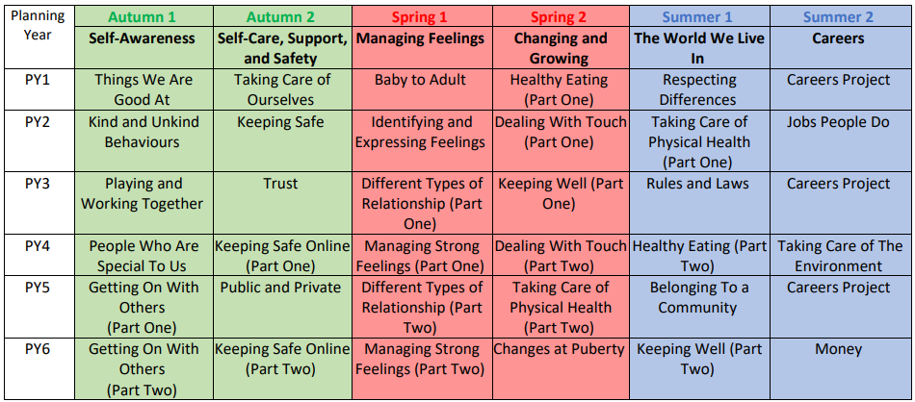

Appendix 2: Key Stage 3 Curriculum map

Appendix 1: Key Stage 4 Curriculum map

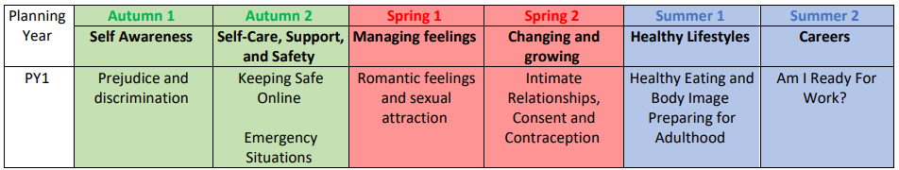

Appendix 4: Parent/carer form: withdrawal from sex education within RSE

To be completed by parents/CARERS
Name of child |  | Class
Name of parent/carer |  | Date
Reason for withdrawing from sex education within relationships and sex education
Any other information you would like the school to consider
Parent signature

To be completed by the school
Agreed actions from discussion with parents/carers

